|  |
| --- |
| **Argentis Consulting** |
| **Apparel & Footwear** |
| DTW - Data Migration of RESOURCE |



**www.sapapparel.com**

Contents

1 INTRODUCTION 3

2 TEMPLATES 3

2.1 Templates related to Resource 3

2.1.1 Template: ARGNS_RESOURCE - ARGNS_RESOURCE 3

3 DATA IMPORT PROCESS 4

3.1 Excel Preparation for Resource 4

4 CSV files import trough DTW –Resource 5

# INTRODUCTION

This document contains the necessary information to prepare and execute data migration for resource using the DTW tool.

# TEMPLATES

## Templates related to Resource

To import data related to Operation template the following Excel templates need to be completed:

1. ARGNS_RESOURCE - ARGNS_RESOURCE

### Template: ARGNS_RESOURCE - ARGNS_RESOURCE

This is the template that will hold the general information for each resource.

The relevant fields in this template are:

1. Code: SAP Internal Code. This code is a sequence starting from 1. It must be unique

2. Name: This should be blank

3. U_ResCode: Resource code

4. U_ResDesc:  Resourcedescription

5. U_WorkCePrCode:  Workcenter code

6. U_Active: ‘Y’ to make active ‘N’ to make inactive

7. U_TypeRCode: Type of resource

8. U_HldCode: Holiday Code

9. U_CapaPla: Capacity Planning

10. U_Cost: Resource cost

11. U_Capacity: Total capacity

12. U_Count: No. of resources

13. U_ResName: Resource Name

14. U_External: ‘Y’ if it is external resource, ‘N’ if in house resource

15. U_Include: ‘Y’ to include in planning, ‘N’ to exclude from planning

# DATA IMPORT PROCESS

## Excel Preparation for Resource

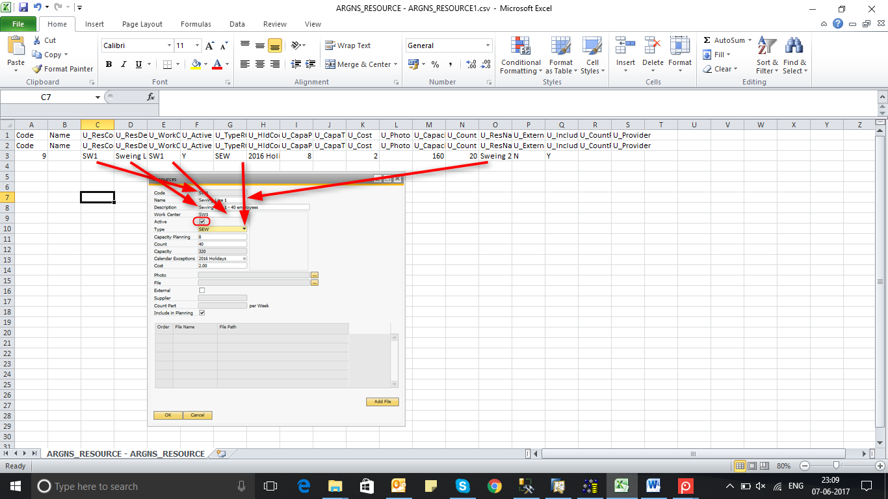

# CSV files import trough DTW –Resource

1. Click on the “Import” button to start the Data import wizard

2. Select master data as the data type for importing POM definition

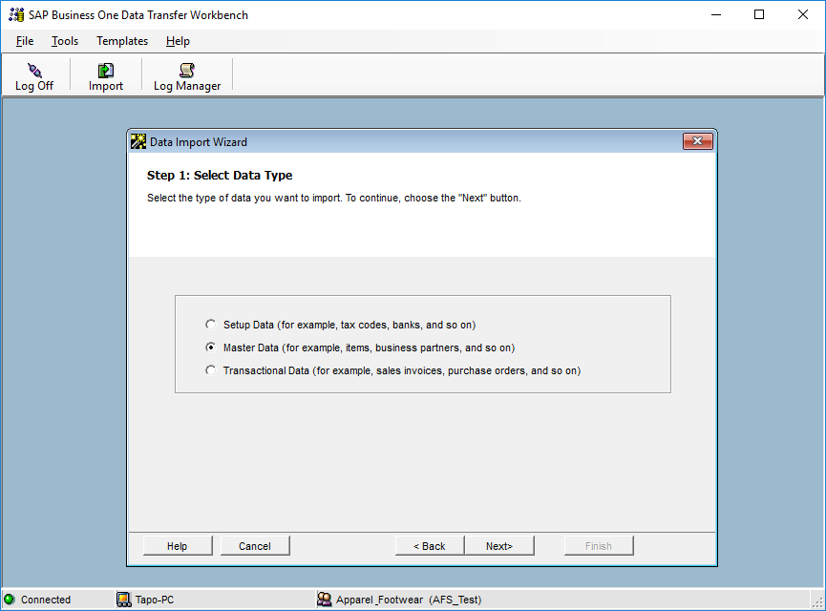

3. Select Add new data as the operation type (Please note that if you are working with already existing

styles, then select the Update existing data option or the Add new data and Update existing data if

you are going to be updating data and loading new data all in the same process).

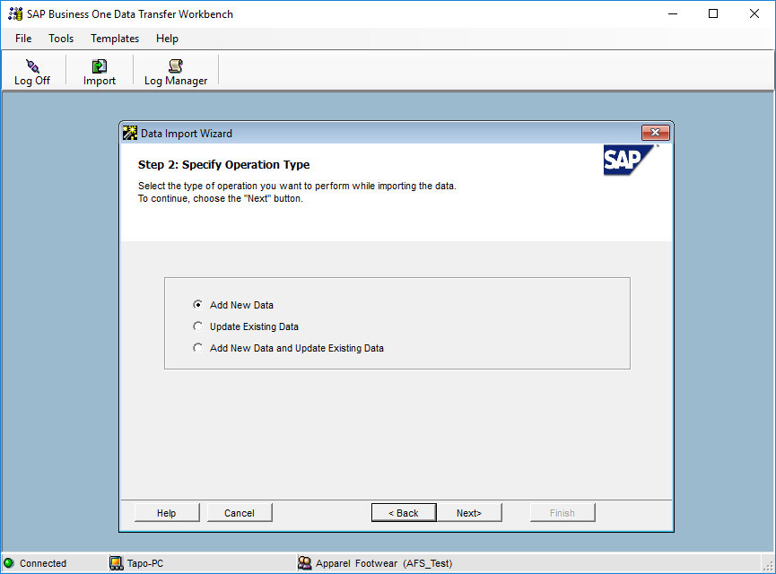

4. Search and select the UDO_ARGNS_RESOURCE object under the following path: User Defined

Data > Object (UDO) > UDO_ARGNS_RESOURCE

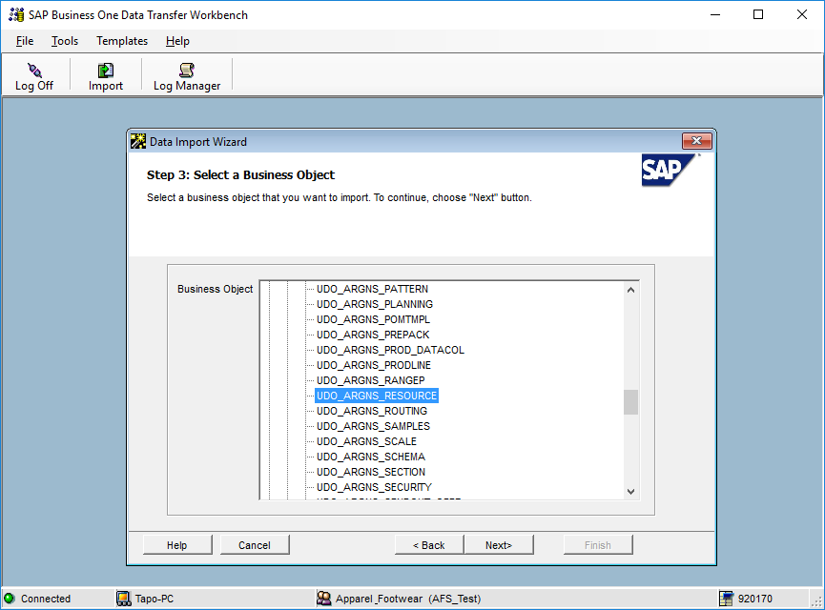

5. Select the templates corresponding to each operation template object.

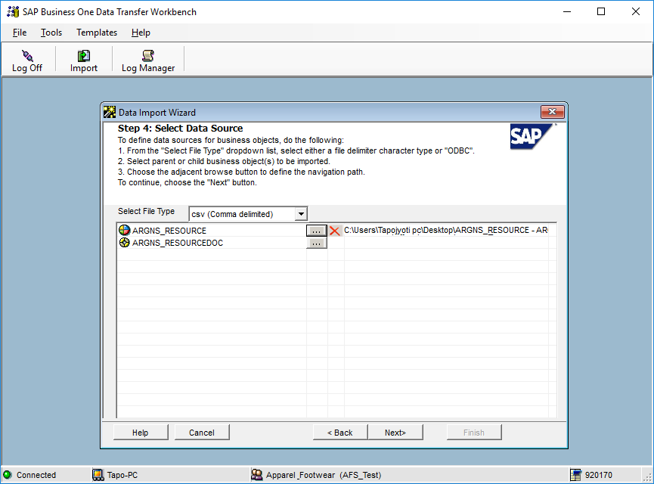

6. Map object fields. This is a confirmation screen for the data mapping.

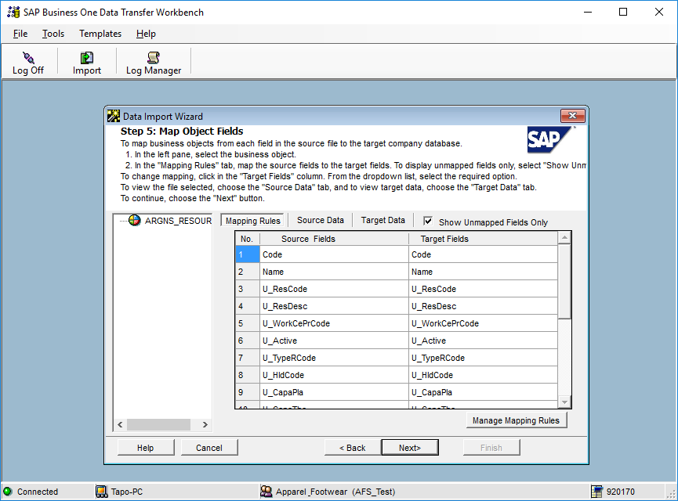

7. Define error handling. It is usually recommended to select the last option to prevent from processing the entire file if a certain number of errors are found. In this step it is usually recommended to run the simulation process (by clicking the Run Simulation button) to get a preview of the data import result.

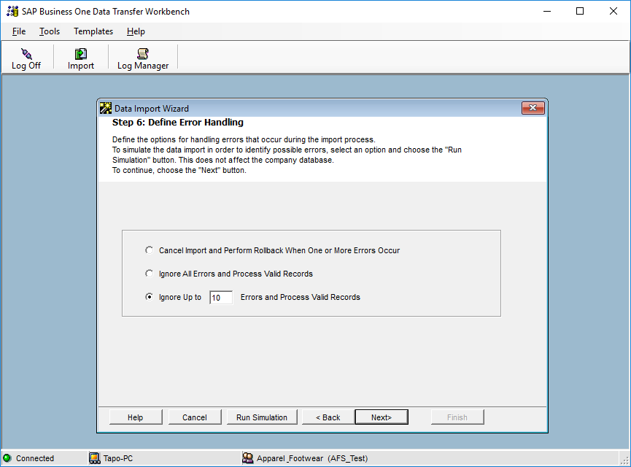

8. Start importing data. If no errors were found in the simulation process, click on the Import button to start the actual data import process. Please not that this does not guarantees that the data imported is accurate and it must be checked within SAP to make sure that everything is being loaded the way it should.



**www.argentisconsulting.com**

**Argentis Consulting** is dedicated to the development, distribution and support of recognized certified solutions for SAP Business One, as an SSP (Software Solution Provider) with a Gold Partner status.

**CONTACT INFORMATION**

|  |  |
| --- | --- |
| **USA**  9744 NW 45th Lane  Doral, FL 33178  info@argentisconsulting.com | **ARGENTINA**  Ávila y Zarate 2048  Cerro de la Rosas, Córdoba,  CP 5009  Córdoba - Argentina  info@argentisconsulting.com |
| **CARIBEAN**  City View Plaza – Suite 301  48 Road 165  Guaynabo, PR. 00968  Puerto Rico  caribe@argentisconsulting.com | **SPAIN**  C/ Juan Bravo N° 3 A 28006  Phone: (+34) 91 123 7263  Madrid - Spain  info@argentisconsulting.com |